1. On the drawing of a neuron below, the structure labeled "1" is
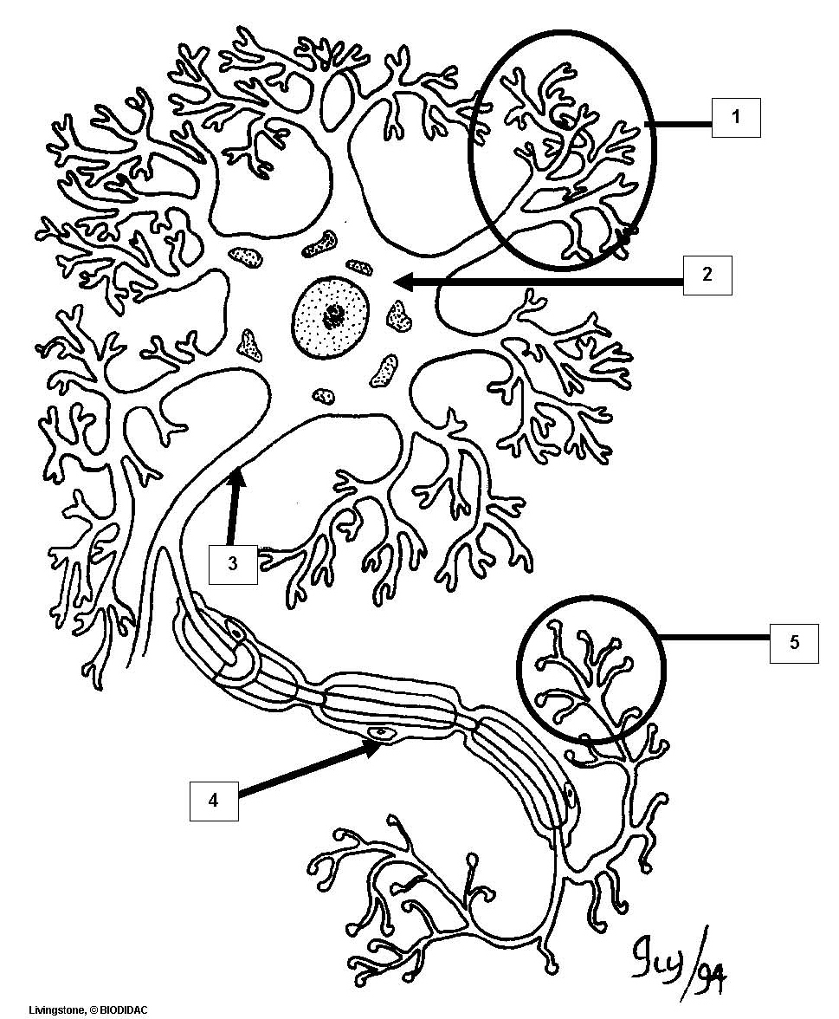

a. axon
b. axon terminals
c. cell body = soma
*d. dendrites
e. Schwann cell

2. On the drawing of a neuron below, the structure labeled "2" is

a. axon
b. axon terminals
*c. cell body = soma
d. dendrites
e. Schwann cell

3. On the drawing of a neuron below, the structure labeled "3" is

*a. axon
b. axon terminals
c. cell body = soma
d. dendrites
e. Schwann cell

4. On the drawing of a neuron below, the structure labeled "4" is

a. axon
b. axon terminals
c. cell body = soma
d. dendrites
*e. Schwann cell

5. On the drawing of a neuron below, the structure labeled "5" is

a. axon
*b. axon terminals
c. cell body = soma
d. dendrites
e. Schwann cell

6. On the drawing of a myelinated axon below, the structure labeled "1" is
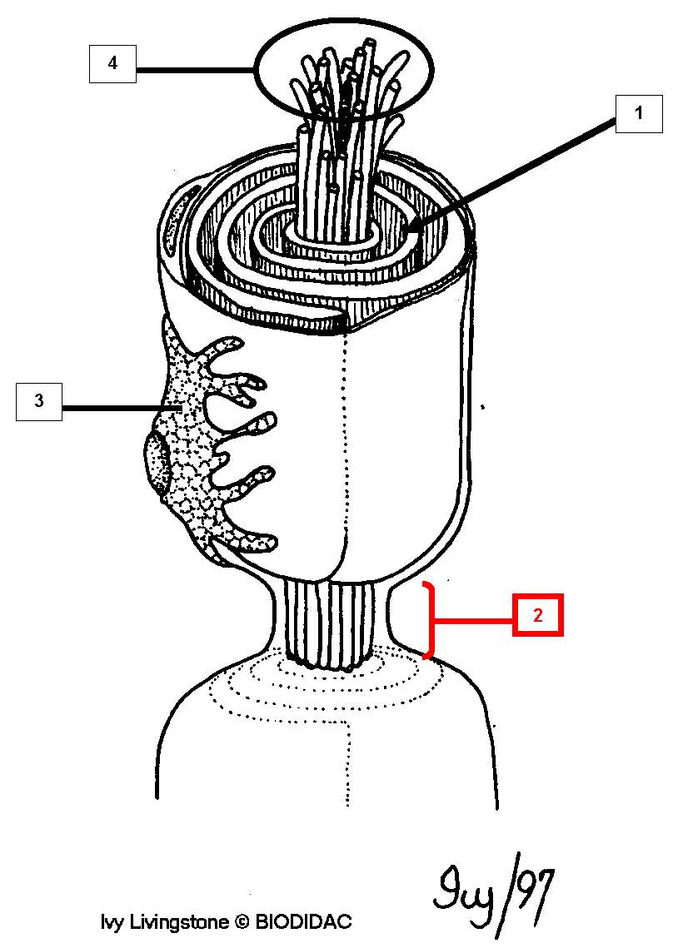

a. axon
*b. myelin sheath
c. node of Ranvier
d. Schwann cell nucleus

7. On the drawing of a myelinated axon below, the structure labeled "2" is

a. axon
b. myelin sheath
*c. node of Ranvier
d. Schwann cell nucleus

8. On the drawing of a myelinated axon below, the structure labeled "3" is

a. axon
b. myelin sheath
c. node of Ranvier
*d. Schwann cell nucleus

9. On the drawing of a myelinated axon below, the structure labeled "4" is

*a. axon
b. myelin sheath
c. node of Ranvier
d. Schwann cell nucleus

10. On the drawing of a spinal cord x-sec below, the structure labeled "1" is
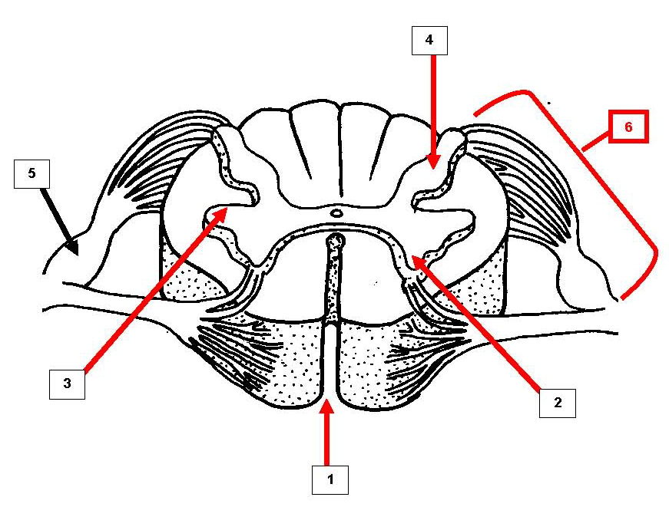

a. dorsal root
b. dorsal root ganglion
c. dorsal gray horn
d. lateral gray horn
e. ventral gray horn
*f. ventral median fissure

11. On the drawing of a spinal cord x-sec below, the structure labeled "2" is

a. dorsal root
b. dorsal root ganglion
c. dorsal gray horn
d. lateral gray horn
*e. ventral gray horn
f. ventral median fissure

12. On the drawing of a spinal cord x-sec below, the structure labeled "3" is

a. dorsal root
b. dorsal root ganglion
c. dorsal gray horn
*d. lateral gray horn
e. ventral gray horn
f. ventral median fissure

13. On the drawing of a spinal cord x-sec below, the structure labeled "4" is

a. dorsal root
b. dorsal root ganglion
*c. dorsal gray horn
d. lateral gray horn
e. ventral gray horn
f. ventral median fissure

14. On the drawing of a spinal cord x-sec below, the structure labeled "5" is

a. dorsal root
*b. dorsal root ganglion
c. lateral gray horn
d. dorsal gray horn
e. ventral gray horn
f. ventral median fissure

15. On the drawing of a spinal cord x-sec below, the structure labeled "6" is

*a. dorsal root
b. dorsal root ganglion
c. lateral gray horn
d. dorsal gray horn
e. ventral gray horn
f. ventral median fissure

16. On the drawing of a spinal cord x-sec below, the structure labeled "1" is
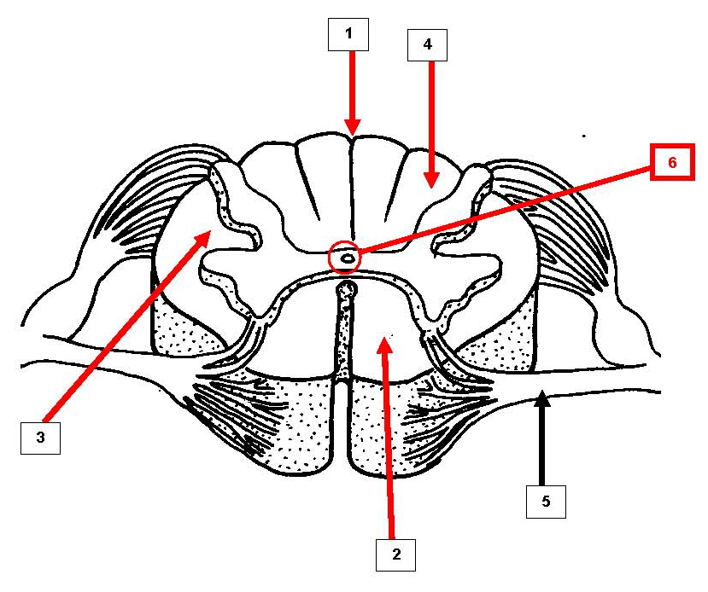

a. central canal
*b. dorsal median sulcus
c. dorsal white column
d. lateral white column
e. ventral root
f. ventral white column

17. On the drawing of a spinal cord x-sec below, the structure labeled "2" is

a. central canal
b. dorsal median sulcus
c. dorsal white column
d. lateral white column
e. ventral root
*f. ventral white column

18. On the drawing of a spinal cord x-sec below, the structure labeled "3" is

a. central canal
b. dorsal median sulcus
c. dorsal white column
*d. lateral white column
e. ventral root
f. ventral white column

19. On the drawing of a spinal cord x-sec below, the structure labeled "4" is

a. central canal
b. dorsal median sulcus
*c. dorsal white column
d. lateral white column
e. ventral root
f. ventral white column

20. On the drawing of a spinal cord x-sec below, the structure labeled "5" is

a. central canal
b. dorsal median sulcus
c. dorsal white column
d. lateral white column
*e. ventral root
f. ventral white column

21. On the drawing of a spinal cord x-sec below, the structure labeled "6" is

*a. central canal
b. dorsal median sulcus
c. dorsal white column
d. lateral white column
e. ventral root
f. ventral white column

22. On the drawing of a spinal cord x-sec below, the structure labeled "1" is
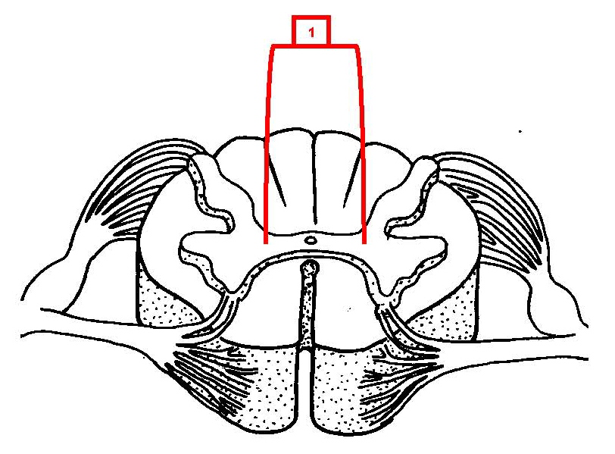

a. central canal
b. dorsal root
*c. gray commissure
d. ventral root
e. white matter

23. On the drawing of a sheep brain (ventral view) below, the structure labeled "1" is
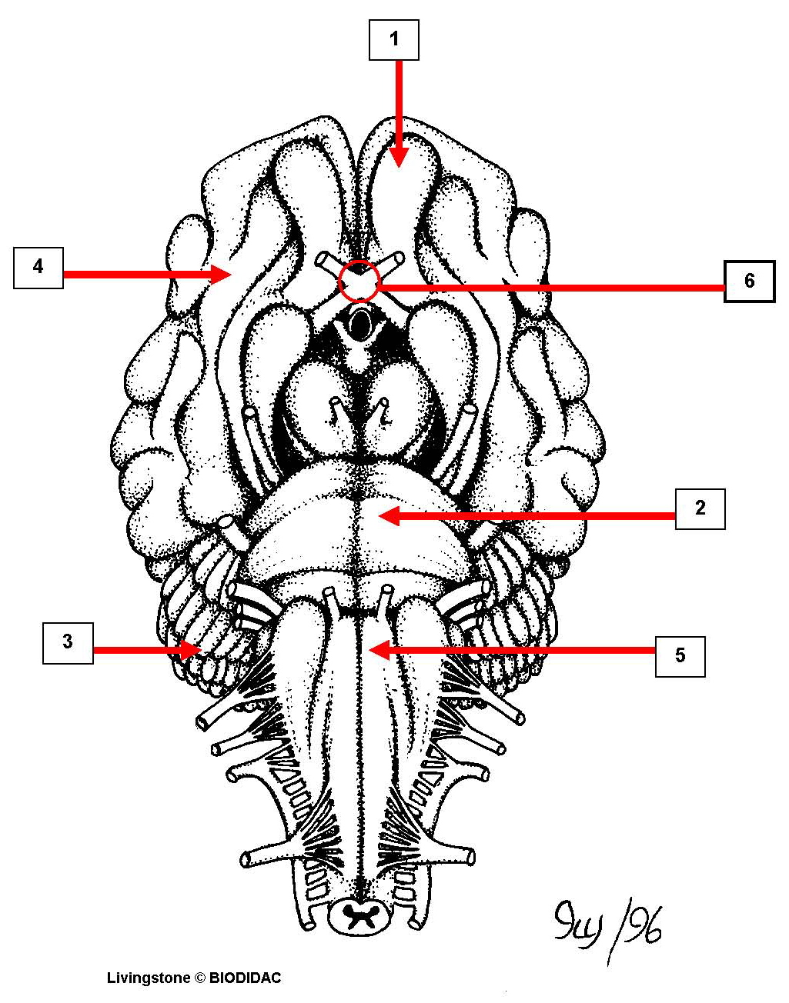

a. cerebellum
b. cerebrum
c. medulla oblongata
*d. olfactory bulb
e. optic chiasma
f. pons

24. On the drawing of a sheep brain (ventral view) below, the structure labeled "2" is

a. cerebellum
b. cerebrum
c. medulla oblongata
d. olfactory bulb
e. optic chiasma
*f. pons

25. On the drawing of a sheep brain (ventral view) below, the structure labeled "3" is

*a. cerebellum
b. cerebrum
c. medulla oblongata
d. olfactory bulb
e. optic chiasma
f. pons

26. On the drawing of a sheep brain (ventral view) below, the structure labeled "4" is

a. cerebellum
*b. cerebrum
c. medulla oblongata
d. olfactory bulb
e. optic chiasma
f. pons

27. On the drawing of a sheep brain (ventral view) below, the structure labeled "5" is

a. cerebellum
b. cerebrum
*c. medulla oblongata
d. olfactory bulb
e. optic chiasma
f. pons

28. On the drawing of a sheep brain (ventral view) below, the structure labeled "6" is

a. cerebellum
b. cerebrum
c. medulla oblongata
d. olfactory bulb
*e. optic chiasma
f. pons

29. On the drawing of a sheep brain (sagittal section), the structure labeled "1" is
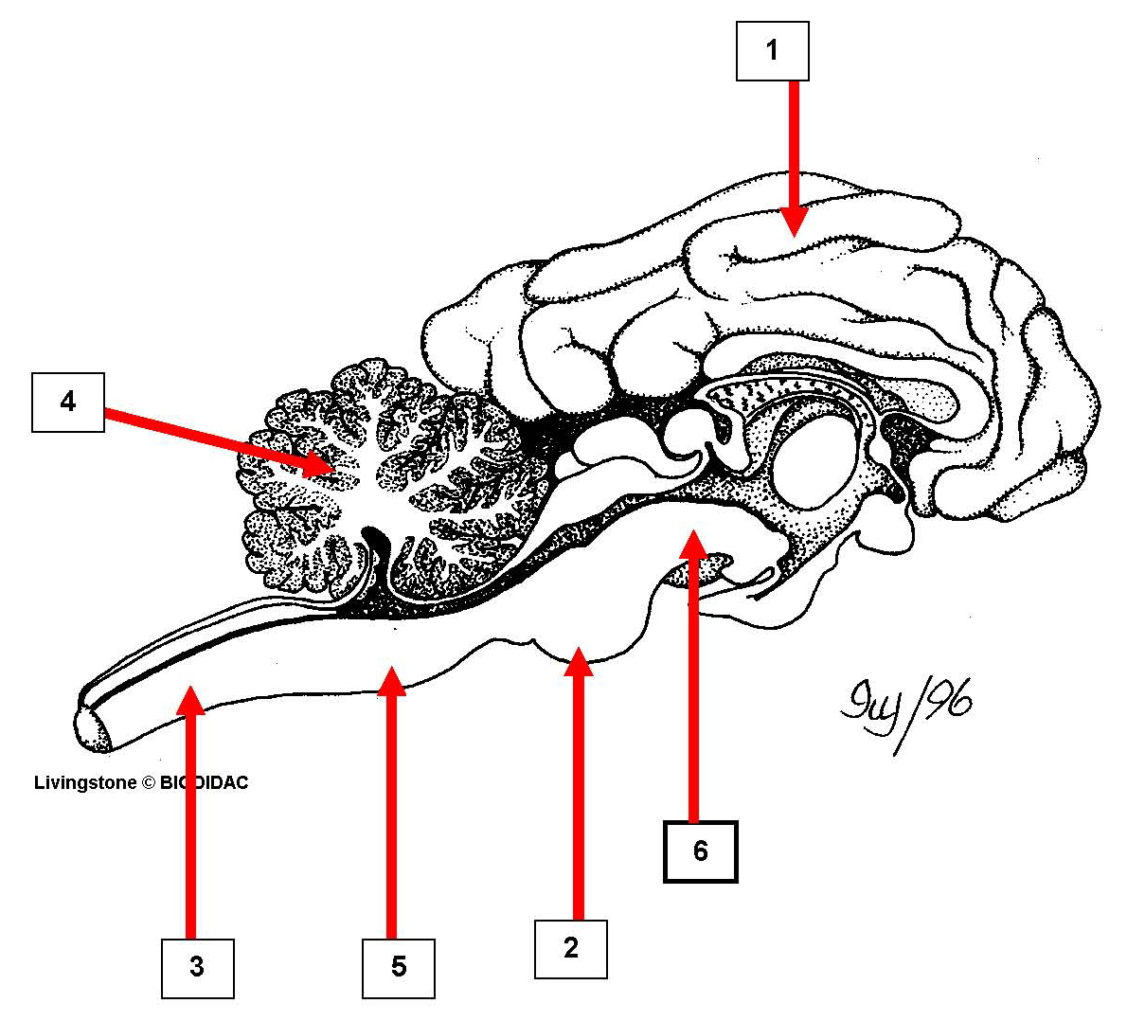

a. cerebellum
*b. cerebrum
c. medulla oblongata
d. midbrain
e. pons
f. spinal cord

30. On the drawing of a sheep brain (sagittal section), the structure labeled "2" is

a. cerebellum
b. cerebrum
c. medulla oblongata
d. midbrain
*e. pons
f. spinal cord

31. On the drawing of a sheep brain (sagittal section), the structure labeled "3" is

a. cerebellum
b. cerebrum
c. medulla oblongata
d. midbrain
e. pons
*f. spinal cord

32. On the drawing of a sheep brain (sagittal section), the structure labeled "4" is

*a. cerebellum
b. cerebrum
c. medulla oblongata
d. midbrain
e. pons
f. spinal cord

33. On the drawing of a sheep brain (sagittal section), the structure labeled "5" is

a. cerebellum
b. cerebrum
*c. medulla oblongata
d. midbrain
e. pons
f. spinal cord

34. On the drawing of a sheep brain (sagittal section), the structure labeled "6" is

a. cerebellum
b. cerebrum
c. medulla oblongata
*d. midbrain
e. pons
f. spinal cord

35. On the drawing of a sheep brain (sagittal section), the structure labeled "1" is
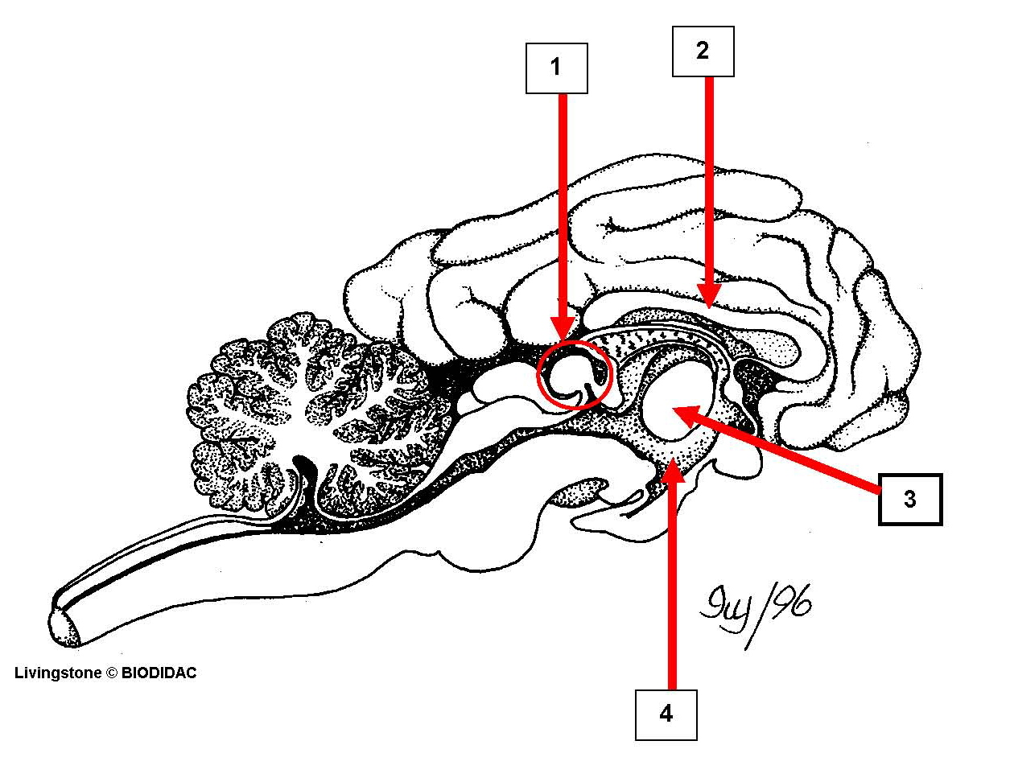

a. corpus callosum
b. hypothalamus
*c. pineal gland
d. thalamus

36. On the drawing of a sheep brain (sagittal section), the structure labeled "2" is

*a. corpus callosum
b. hypothalamus
c. pineal gland
d. thalamus

37. On the drawing of a sheep brain (sagittal section), the structure labeled "3" is

a. corpus callosum
b. hypothalamus
c. pineal gland
*d. thalamus

38. On the drawing of a sheep brain (sagittal section), the structure labeled "4" is

a. corpus callosum
*b. hypothalamus
c. pineal gland
d. thalamus

